**KENDRIYA VIDYALAYA ONGC**

**JORHAT, ASSAM**



***Academic Year: 2022-23***

*A project report on*

*STATIONARY MANAGEMENT*

**Submitted By: Submitted to:**

*Debasish Hazarika Mahesh Chand Pal*

*Class XII*

*Roll no.- 16657615*

|  |  |  |
| --- | --- | --- |
| **TABLE OF CONTENTS** | | |
| Sno. | Description | Page No. |
| 01 | ACKNOWLEDGEMENT | **3** |
| 02 | GETTING STARTED | **4** |
| 03 | CODE | **5-18** |
| 04 | OUTPUT | **19-28** |
| 05 | BIBLIOGRAPHY | **29** |

**ACKNOWLEDGEMENT**

*I am grateful and feel thankful to our Computer Science teacher, Mr. Mahesh Chand Pal. It was his unfailing push and constant inspiration that his work could take the present shape.*

*Turning aspirations into reality and guiding us in each step to accomplish the task and complete this project successfully.*

**GETTING STARTED**

**SOME REQUIREMENTS**

1. Pycharm latest version required.
2. MySql latest version required.
3. PrettyTable package need to be downloaded in pycharm. To install PrettyTable, Go to file, settings, project settings, project interpreter, click on the plus icon to install new package and just search an install ‘prettytable’ .
4. Use monospaced font for best experience.
5. Also go to File, Settings, Editor, Font, and enable ligature feature for better experience. This feature use several characters as a single ligature, and enhances the code readability.

**INITIALIZING PROJECT**

To create database, open create_database.py and run it. It should create required databases to run the main program. It also add some stationary item data for the ease to check the program.

**CODE**

**Create_database.py**

import pickle  
import mysql.connector as ms  
  
pswrd = input('Enter your mysql server password: ')  
  
mydb = ms.connect(host='localhost', user='root', password=pswrd)  
my_cursor = mydb.cursor()  
file = open('rows.bin', 'rb')  
table_rows = pickle.load(file)  
  
my_cursor.execute('Create database stationary_manager')  
my_cursor.execute('use stationary_manager')  
my_cursor.execute('create table items(ItemNo int primary key Auto_increment,'  
 'Item_name varchar(30),'  
 'Stock int,price float(10, 2),'  
 'Added_On timestamp default current_timestamp)')  
my_cursor.execute('create table users(UserId int primary key,'  
 'UserName varchar(30),'  
 'First_Logged_in timestamp default current_timestamp(),'  
 'Last_Logged_in timestamp default current_timestamp())')  
  
query = 'insert into items values(%s, %s, %s, %s, %s)'  
my_cursor.executemany(query, table_rows)  
mydb.commit()  
print('Database imported successfully!')  
  
  
file.close()

**MAIN.PY**

import functions

program_finished = False

main_menu_op = (('Enter 1 to display all Items',),

('Enter 2 to search Item details',),

('Enter 3 to add Items',),

('Enter 4 to modify Items',),

('Enter 5 to remove Items',),

('Enter 6 to manage users',),

('Enter 7 to exit',))

user_op = (('Enter 1 to display all users',),

('Enter 2 to search users',),

('Enter 3 to change username',),

('Enter 4 to delete Items',),

('Enter 5 to go back to main menu',))

username = functions.log_in()

while not program_finished:

print(functions.table_display(main_menu_op, ['Main Menu']))

choice = input('-> ')

while type(choice) is str:

if choice.isdigit():

if int(choice) in range(1, 8):

choice = int(choice)

else:

print('Enter a valid choice')

choice = input()

else:

print('Enter a valid choice')

choice = input()

if choice == 1:

print(functions.display_items())

input('Press Enter to go to Main Menu')

elif choice == 2:

print(functions.search())

input('Press Enter to go to Main Menu')

elif choice == 3:

functions.add_items()

input('Press Enter to go to Main Menu')

elif choice == 4:

functions.modify()

input('Press Enter to go to Main Menu')

elif choice == 5:

functions.remove()

input('Press Enter to go to Main Menu')

elif choice == 6:

managing_users = True

while managing_users:

print(functions.table_display(user_op, ['Manage Users']))

user_choice = input('-> ')

if user_choice == '1':

print(functions.see_users())

input('Enter to go back')

elif user_choice == '2':

print(functions.search_user())

input('Enter to go back')

elif user_choice == '3':

functions.change_username()

input('Enter to go back')

elif user_choice == '4':

functions.delete_users()

input('Enter to go back')

elif user_choice == '5':

managing_users = False

elif choice == 7:

program_finished = True

print('Program exited...')

functions.close(username)

**FUNCTIONS.PY**

import mysql.connector as ms

from prettytable import PrettyTable

from datetime import datetime

def get_pswrd():

password = input('Enter your mysql server password: ')

return password

mydb = ms.connect(host='localhost', user='root', password=get_pswrd(), database='stationary_manager')

my_cursor = mydb.cursor()

user_atr = ('UserId', 'Username', 'FirstLogged-in', 'LastLogged-in')

item_atr = ('ItemNo', 'Item_name', 'Stock', 'price(in Rs)', 'Added_On')

def table_display(row, atr=item_atr):

"""Displays tubular data in ASCII table format"""

table = PrettyTable()

table.field_names = atr

table.add_rows(row)

return table

def display_items(query='select * from items', atr=item_atr):

"""Display data in tabular form just like in mysql"""

my_cursor.execute(query)

rows = my_cursor.fetchall()

if len(rows) == 0:

return rows

return table_display(rows, atr)

def search():

# select search method

print('''Enter 1 to search by Item Name

Enter 2 to search by price

Enter 3 to search by date added''')

choice = input()

if choice == '1':

item_name = input('Enter the product name\n')

query = f'select * from items where Item_name="{item_name}"'

output = display_items(query)

if type(output) is list:

return f"No item named '{item_name}' is available"

else:

return output

elif choice == '2':

print('''Enter 1 to enter a specific price

Enter 2 to enter price range''')

choice = int(input())

if choice == 1:

price = input('Enter the price\n')

query = f'select * from items where price = {price}'

output = display_items(query)

if type(output) is list:

return f'No items of price {price}'

else:

return display_items(query)

elif choice == 2:

min_price = input("Enter starting price\n")

max_price = input("Enter max price\n")

query = f'select * from items where price>={min_price} and price<={max_price}'

return display_items(query)

elif choice == '3':

print('''Enter 1 to search items added on a day

Enter 2 to search items added on range of days''')

date_method = int(input())

if date_method == 1:

year = int(input('Enter year: '))

month = int(input('Enter month: '))

date = int(input('Enter date: '))

date2 = datetime(year, month, date + 1)

date = datetime(year, month, date)

output = display_items(f'select * from items where added_on >"{date}" and added_on <"{date2}"')

elif date_method == 2:

year_1 = int(input('Enter year_1: '))

month_1 = int(input('Enter month_1: '))

date_1 = int(input('Enter date_1: '))

year_2 = int(input('Enter year_2: '))

month_2 = int(input('Enter month_2: '))

date_2 = int(input('Enter date_2: '))

date1 = datetime(year_1, month_1, date_1)

date2 = datetime(year_2, month_2, date_2+1)

output = display_items(f'select * from items where added_on >"{date1}" and added_on <"{date2}"')

if type(output) is list:

return f"No items found..."

else:

return output

def add_items():

items = int(input('How many items you want to add?\n'))

val = []

item_names = []

modification = False

for n in range(items):

modification = False

if items > 1:

print(f'Enter item {n+1}')

else:

print('Enter Item-Name')

item_name = input()

if item_name.lower() in eval((str(get_column(column_no=2)).lower())):

print(f'{item_name} already exists. Do you want to update instead? Enter "y" or "n"')

to_update = input()

if to_update == 'y':

modify(item_name)

modification = True

else:

stock = int(input('Enter stock\n'))

price = float(input('Enter the price\n'))

val.append((item_name, stock, price))

item_names.append(item_name)

if modification is False:

query = 'insert into items(Item_name, stock, price) values(%s, %s, %s)'

my_cursor.executemany(query, val)

mydb.commit()

if len(item_names) == 1:

item_names = f'("{item_names[0]}")'

else:

item_names = tuple(item_names)

print('The following items were added.')

print(display_items(f'select * from items where item_name in {item_names}'))

def modify(item_name=None):

to_continue1 = True

is_modified = False

while to_continue1:

if item_name is None:

item_name = input('Enter the item name you want to modify\n')

else:

print(f'Updating {item_name}...\n')

if item_name.lower() not in eval(str(get_column(column_no=2)).lower()):

print(f'No item named {item_name} was found')

print("Do you want to add items? Enter 'y' or 'n'")

choice = input()

if choice == 'y':

add_items()

break

else:

break

to_continue2 = True

while to_continue2:

print('''Enter 1 to change the price

Enter 2 to add to stock

Enter 3 to remove from stock''')

choice = int(input())

if choice == 1:

new_price = input('Enter new price in Rs\n')

my_cursor.execute(f'update items set price={new_price} where item_name="{item_name}"')

is_modified = True

elif choice == 2:

add_stock = int(input('Enter the number of new items you are adding\n'))

old_stock = get_column('items', 3, item_name)

stock = old_stock[0] + add_stock

my_cursor.execute(f'update items set stock={stock} where item_name = "{item_name}"')

is_modified = True

elif choice == 3:

old_stock = get_column('items', 3, item_name)

if old_stock[0] == 0:

print('This item is out of stock')

elif old_stock[0] != 0:

sub_stock = int(input('Enter the number of items to be removed: '))

if old_stock[0] < sub_stock:

stock = 0

my_cursor.execute(f'update items set stock={stock} where item_name = "{item_name}"')

else:

stock = old_stock[0] - sub_stock

my_cursor.execute(f'update items set stock={stock} where item_name = "{item_name}"')

is_modified = True

if is_modified:

print("Modification done successfully...")

print(display_items(f'select * from items where Item_name="{item_name}"'), '\n\n')

mydb.commit()

print(f'Do you want continue modifying the item "{item_name}"? Enter "y" or "n".')

to_continue = input().lower()

if to_continue == 'n':

to_continue2 = False

print(f'Do you want modifications to other items? enter "y" or "n"')

to_continue = input().lower()

if to_continue == 'n':

to_continue1 = False

def remove():

item_name = input("Enter the item name to be removed\n")

print('The following item was deleted...')

display_items(f'select * from items where item_name="{item_name}"')

my_cursor.execute(f'delete from items where item_name="{item_name}"')

def get_column(table_name='items', column_no=1, item_name=None):

"""Returns the list of values of the passed column"""

if item_name is not None:

my_cursor.execute(f'select * from {table_name} where item_name = "{item_name}"')

else:

my_cursor.execute(f'select * from {table_name}')

column = []

for row in my_cursor:

column.append(row[column_no-1])

return column

def see_users():

my_cursor.execute('select * from users')

rows = my_cursor.fetchall()

return table_display(rows, user_atr)

def search_user():

username = input('Enter username: ')

my_cursor.execute(f'select * from users where username="{username}"')

users = my_cursor.fetchall()

if len(users) > 0:

return table_display(users, user_atr)

else:

return f'No user named "{username}" was found...'

def change_username():

old_name = input('Enter the username you want to change: ')

if old_name.lower() in eval(str(get_column('users', 2, )).lower()):

new_name = input('Enter the new username: ').title()

my_cursor.execute(f'update users set username = "{new_name}" where username = "{old_name}"')

print(display_items(f'select * from users where username="{new_name}"', user_atr))

mydb.commit()

else:

print(f'No user named "{old_name}" was found...')

def delete_users():

username = input('Enter the username you want to delete: ')

if username.lower() in eval(str(get_column('users', 2, )).lower()):

print('Following user was deleted...')

print(display_items(f'select * from users where username="{username}"', user_atr))

my_cursor.execute(f'delete from users where username="{username}"')

mydb.commit()

else:

print(f'No user named "{username}" was found...')

def sign_up():

print('Looks like you are new, please login\n')

name_valid = False

full_name = ''

while not name_valid:

f_name = input('Enter your first name\n').capitalize()

l_name = input('Enter your last name\n').capitalize()

full_name = f'{f_name} {l_name}'

if full_name in get_column('users', 2):

print('Username already exists!')

else:

name_valid = True

no_of_users = len(get_column('users'))

if no_of_users == 0:

user_id = 1

else:

user_id = no_of_users+1

print(f'Your user id is {user_id}')

q = 'insert into users(UserId, UserName) values(%s, %s)'

val = (user_id, full_name)

my_cursor.execute(q, val)

mydb.commit()

print(f'signed_in successfully! Welcome {full_name}')

return full_name

def log_in():

user = input('Enter your username\n').title()

while True:

if user in get_column('users', 2):

print(f'Hello {user}')

return user

else:

sign_up()

break

def log_out(username):

my_cursor.execute(f'update users set Last_Logged_in=current_timestamp() where username = "{username}"')

mydb.commit()

def close(username):

log_out(username)

mydb.close()

**OUTPUT**

**Output of create_database.py**

Enter your mysql server password: **students**

Database imported successfully!

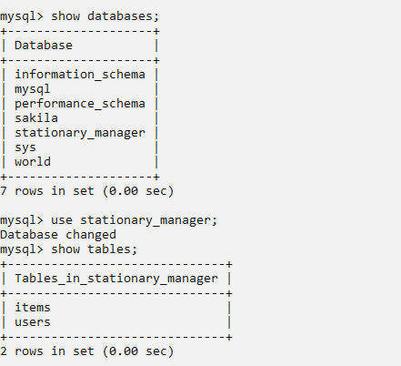

**Structure of tables**

Items table

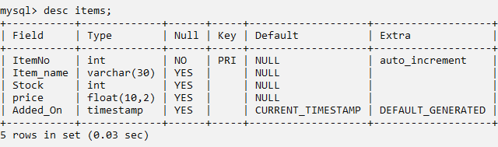

Users table

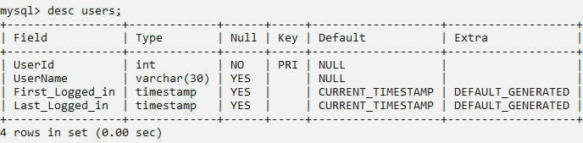

**Main Program**

Main menu

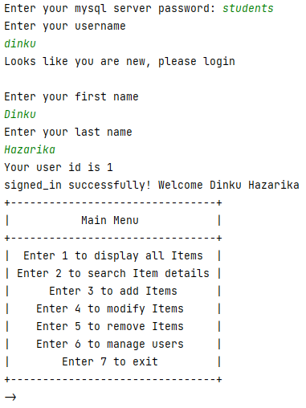

1. **Display all Items**

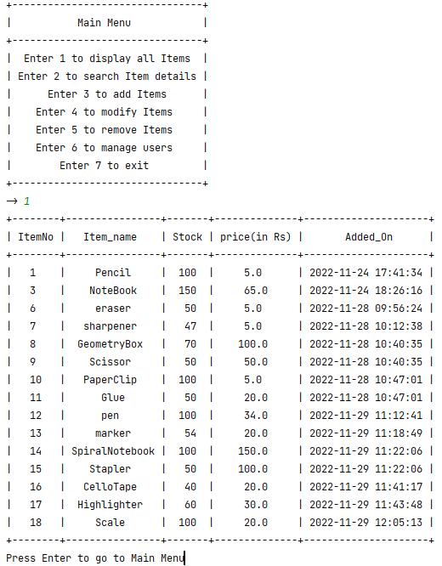

1. **Search Items**

Search by name

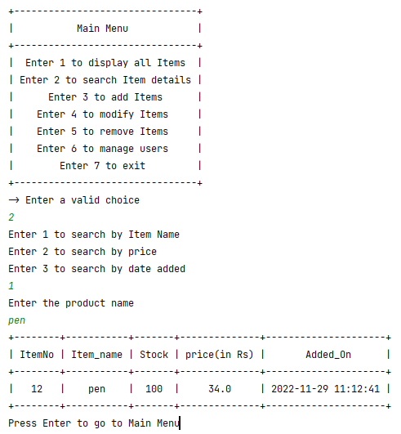

Search by price

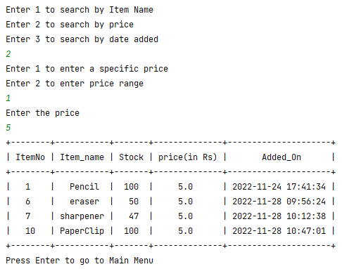

1. **Add Items**

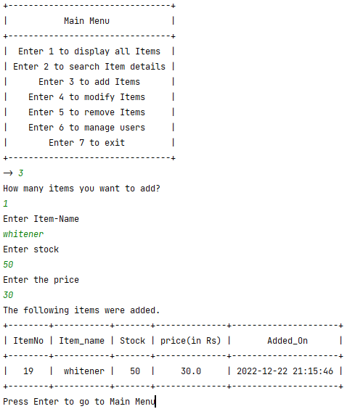

1. Modify Items

Change Price

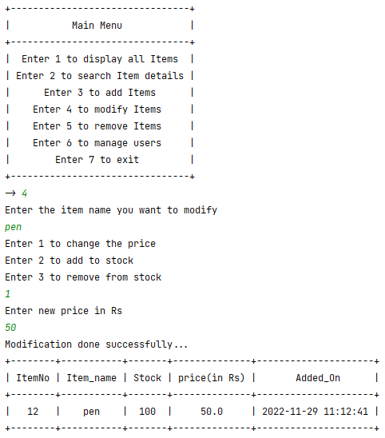

Add Stock

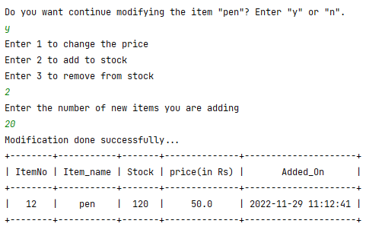

1. Remove Items

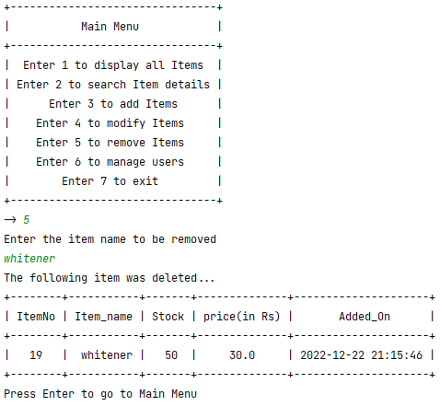

1. Managing Users

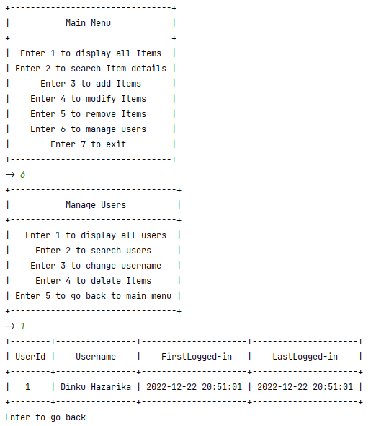

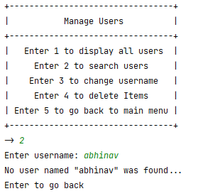

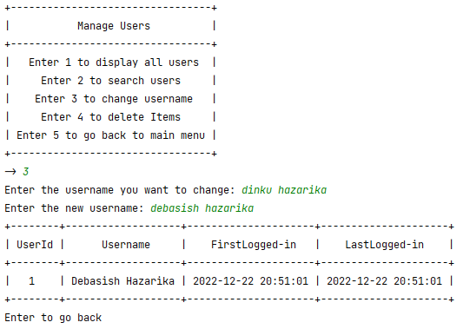

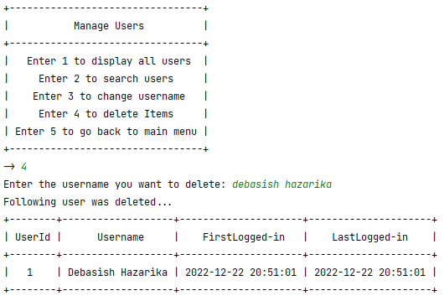

**BIBLIOGRAPHY**



